**Lab Activity 10: Graphic usage using PHP**

**Summary**

This lab focused on using PHP's GD library to dynamically generate images. Through a series of exercises, I implemented various image creation techniques including:

* Creating basic images with colored backgrounds and text
* Drawing geometric shapes (rectangles, circles, lines)
* Generating dynamic content (random numbers, personalized text)
* Using TrueType fonts for professional typography
* Outputting images in PNG format

The lab emphasized practical implementation of GD library functions to solve real-world web development scenarios like creating banners, sale indicators, and personalized greetings.

Screenshots of Implementation

**1. Welcome Banner (Part A1)**  
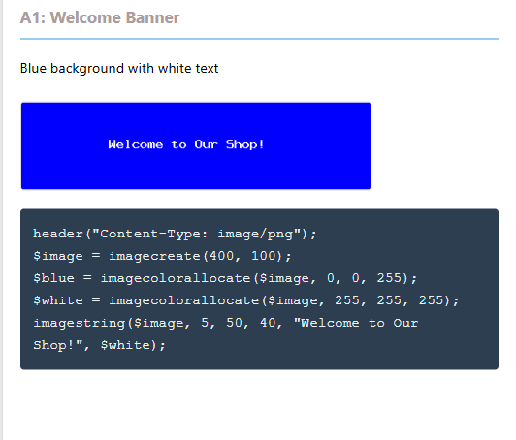**2. Sale Indicator (Part A2)**  
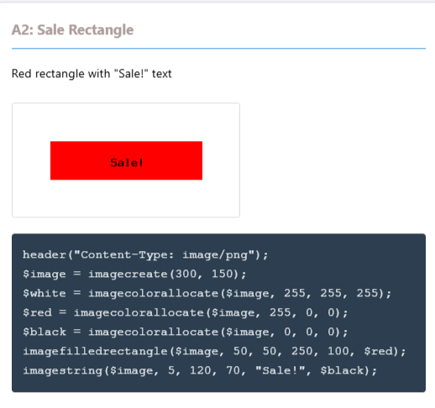

**3. Products Sold Counter (Part B1)**  
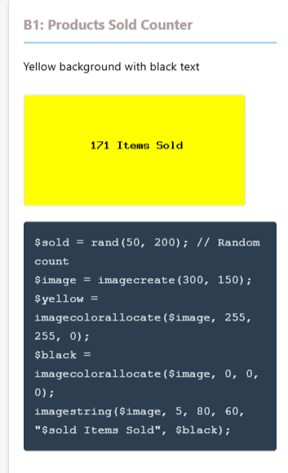

**4. Geometric Shapes (Part B2)**  
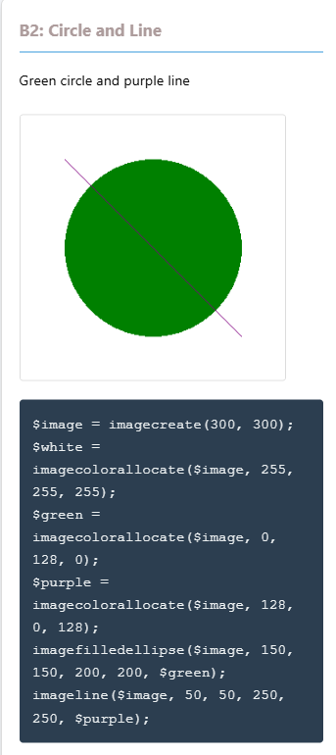

**5. Personalized Greeting (Part B3)**  
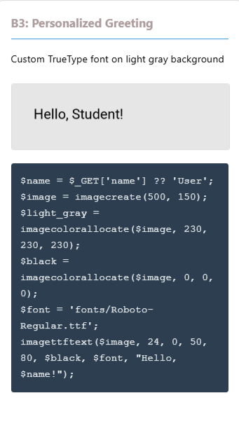

**2. Reflective Journal**

Learning Experience

This lab provided hands-on experience with PHP's image generation capabilities, which I found both challenging and rewarding. The process of creating images programmatically was completely new to me, and it revealed how powerful PHP can be beyond just HTML generation.

I started with basic image creation using imagecreate() and gradually progressed to more complex operations like drawing shapes with imagefilledrectangle() and imagefilledellipse(). The most valuable lesson was learning to use TrueType fonts with imagettftext(), which gives professional-looking results compared to the basic imagestring().

Challenges and Solutions

The main challenge was configuring the GD library. Initially, my images wouldn't display because GD wasn't properly enabled. Through troubleshooting, I learned to:

1. Verify GD installation with phpinfo()
2. Properly edit php.ini to enable the extension
3. Restart the web server after configuration changes

Another challenge was font path resolution. I learned to use __DIR__ for absolute paths and implement error handling to detect missing font files.

**Personal Feelings**

I felt excited when my first image appeared correctly, but frustrated during the initial setup phase. The GD library has a somewhat steep learning curve due to its low-level functions, but the results are extremely satisfying. I particularly enjoyed creating the personalized greeting with custom fonts - it felt like a professional touch I could add to future projects.

The experience made me appreciate how much work goes into simple web elements like banners and indicators. What looks like a basic image actually requires careful programming to generate dynamically.

**Conclusion**

This lab transformed my understanding of PHP's capabilities beyond text-based web development. While challenging at first, the GD library offers powerful tools for creating dynamic visual content. The experience taught me valuable lessons in both programming and system configuration. I now feel confident to implement image generation in future web projects, though I recognize the importance of performance optimization for real-world applications.